**PROJECT- 2**

**CREATING THE SERVER AND INSTALLING THE PACKAGES**

**BY-Parmjeet Singh Kainth**

**HTTP SERVICE**

┌─[root@parrot]─[/home/megha]

└──╼ #service apache2 status

● apache2.service - The Apache HTTP Server

Loaded: loaded (/lib/systemd/system/apache2.service;

Active: inactive (dead)

Jul 16 21:15:10 parrot systemd[1]: Started The Apache HT

Jul 16 21:17:18 parrot systemd[1]: Stopping The Apache H

Jul 16 21:17:18 parrot apachectl[3520]: AH00558: apache2

Jul 16 21:17:18 parrot systemd[1]: Stopped The Apache HT

Jul 16 21:17:18 parrot systemd[1]: Starting The Apache H

Jul 16 21:17:18 parrot apachectl[3525]: AH00558: apache2

Jul 16 21:17:18 parrot systemd[1]: Started The Apache HT

Jul 16 21:17:27 parrot systemd[1]: Stopping The Apache H

Jul 16 21:17:27 parrot apachectl[3566]: AH00558: apache2

lines 1-13

[2]+ Stopped service apache2 status

┌─[✗]─[root@parrot]─[/home/megha]

└──╼ #service apache2 restart

┌─[root@parrot]─[/home/megha]

└──╼ #service apache2 status

● apache2.service - The Apache HTTP Server

Loaded: loaded (/lib/systemd/system/apache2.service;

Active: active (running) since Mon 2018-07-16 21:17:5

Process: 3593 ExecStart=/usr/sbin/apachectl start (cod

Main PID: 3597 (apache2)

Tasks: 7 (limit: 4915)

CGroup: /system.slice/apache2.service

├─3597 /usr/sbin/apache2 -k start

├─3599 /usr/sbin/apache2 -k start

├─3600 /usr/sbin/apache2 -k start

├─3601 /usr/sbin/apache2 -k start

├─3602 /usr/sbin/apache2 -k start

├─3603 /usr/sbin/apache2 -k start

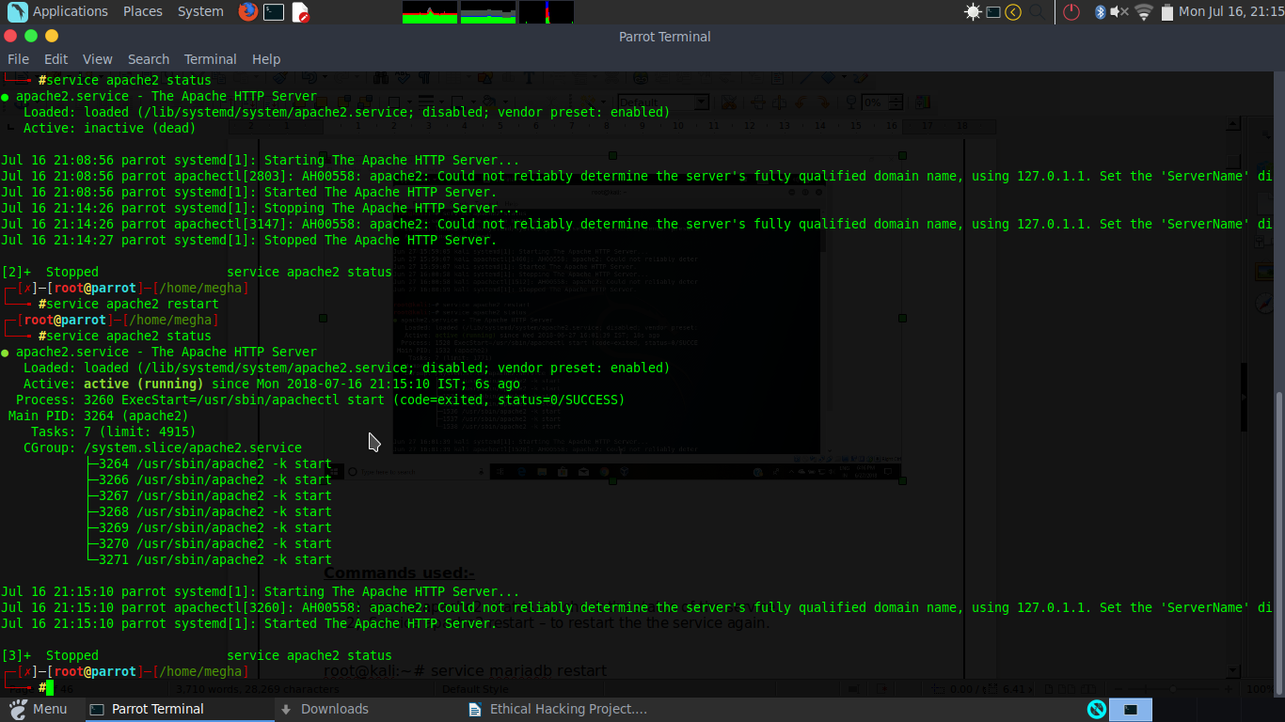

**Commands used:-**

1. service apache2 status –to check the status of the service.
2. Service apache2 restart – to restart the the service again.

**MYSQL SERVICE**

[root@parrot]─[/home/megha]

└──╼ #service mariadb status

● mariadb.service - MariaDB database server

Loaded: loaded (/lib/systemd/system/mariadb.service;

Active: inactive (dead)

[4]+ Stopped service mariadb status

┌─[✗]─[root@parrot]─[/home/megha]

└──╼ #service mariadb restart

┌─[root@parrot]─[/home/megha]

└──╼ #service mariadb status

● mariadb.service - MariaDB database server

Loaded: loaded (/lib/systemd/system/mariadb.service;

Active: active (running) since Mon 2018-07-16 21:16:4

Process: 3475 ExecStartPost=/bin/sh -c systemctl unset

Process: 3472 ExecStartPost=/etc/mysql/debian-start (c

Process: 3358 ExecStartPre=/bin/sh -c [ ! -e /usr/bin/

Process: 3356 ExecStartPre=/bin/sh -c systemctl unset-

Process: 3355 ExecStartPre=/usr/bin/install -m 755 -o

Main PID: 3445 (mysqld)

Status: "Taking your SQL requests now..."

Tasks: 26 (limit: 4915)

CGroup: /system.slice/mariadb.service

└─3445 /usr/sbin/mysqld

[5]+ Stopped service mariadb status

┌─[✗]─[root@parrot]─[/home/megha]

└──╼ #mysql -u root -p

Enter password:

Welcome to the MariaDB monitor. Commands end with ; or \g.

Your MariaDB connection id is 2

Server version: 10.1.26-MariaDB-1 Debian unstable

Copyright (c) 2000, 2017, Oracle, MariaDB Corporation Ab and others.

Type 'help;' or '\h' for help. Type '\c' to clear the current input statement.

MariaDB [(none)]> show databases;

+--------------------+

| Database |

+--------------------+

| information_schema |

| mysql |

| performance_schema |

+--------------------+

3 rows in set (0.03 sec)

MariaDB [(none)]> use mysql;

Reading table information for completion of table and column names

You can turn off this feature to get a quicker startup with -A

Database changed

MariaDB [mysql]> show tables;

+---------------------------+

| Tables_in_mysql |

+---------------------------+

| column_stats |

| columns_priv |

| db |

| event |

| func |

| general_log |

| gtid_slave_pos |

| help_category |

| help_keyword |

| help_relation |

| help_topic |

| host |

| index_stats |

| innodb_index_stats |

| innodb_table_stats |

| plugin |

| proc |

| procs_priv |

| proxies_priv |

| roles_mapping |

| servers |

| slow_log |

| table_stats |

| tables_priv |

| time_zone |

| time_zone_leap_second |

| time_zone_name |

| time_zone_transition |

| time_zone_transition_type |

| user |

+---------------------------+

30 rows in set (0.00 sec)

MariaDB [mysql]> exit

Bye

┌─[root@parrot]─[/home/megha]

└──╼ #

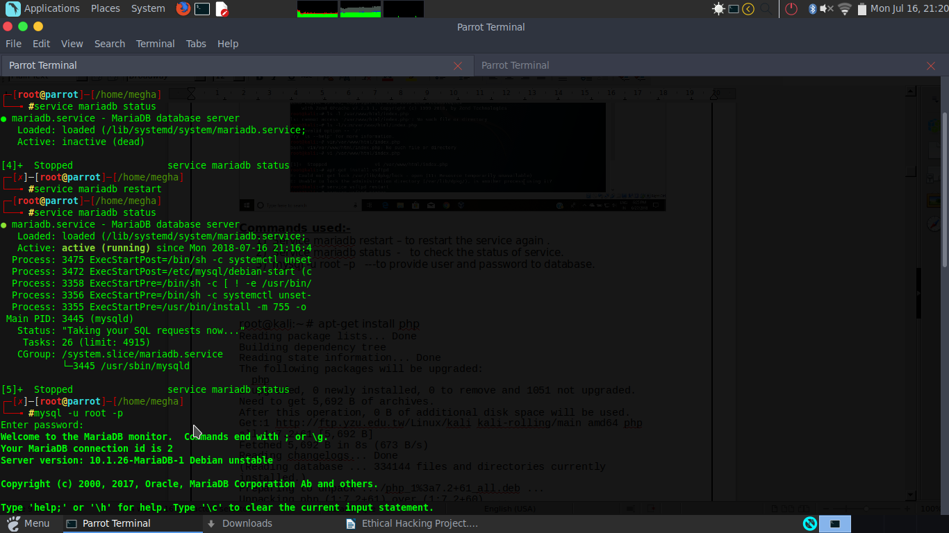

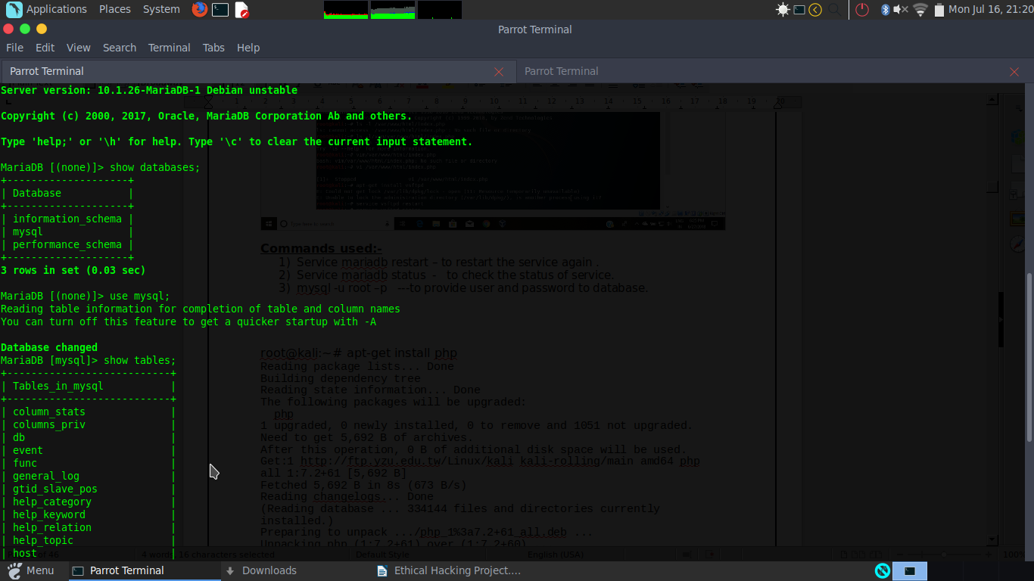

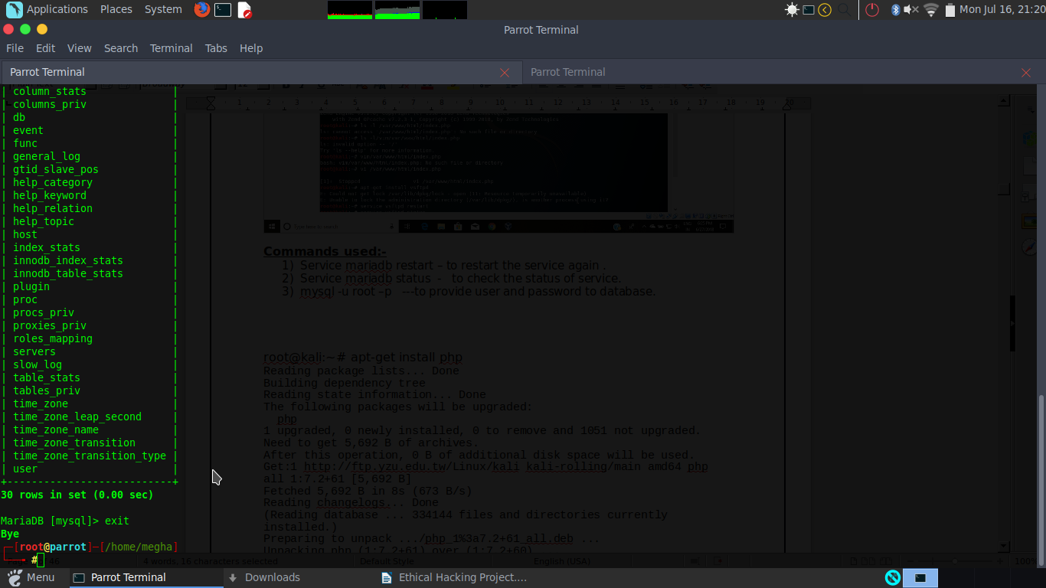

**Commands used:-**

1. Service mariadb restart – to restart the service again .
2. Service mariadb status - to check the status of service.
3. mysql -u root –p ---to provide user and password to database.

**PHP SERVICE**

[root@parrot]─[/home/megha]

└──╼ #apt-get install php-cli php-common

Reading package lists... Done

Building dependency tree

Reading state information... Done

The following additional packages will be installed:

libargon2-0 libc-bin libc-dev-bin libc-l10n libc6 libc6-dbg libc6-dev libclass-xsaccessor-perl libgdbm-compat4 libgdbm5 libncurses6 libperl5.26 libsodium23

libtinfo6 locales locales-all perl perl-base perl-modules-5.26 php7.2-cli php7.2-common php7.2-json php7.2-opcache php7.2-readline

Suggested packages:

glibc-doc gdbm-l10n perl-doc php-pear

The following NEW packages will be installed:

libargon2-0 libgdbm-compat4 libgdbm5 libncurses6 libsodium23 libtinfo6 php-cli php7.2-cli php7.2-common php7.2-json php7.2-opcache php7.2-readline

The following packages will be upgraded:

libc-bin libc-dev-bin libc-l10n libc6 libc6-dbg libc6-dev libclass-xsaccessor-perl libperl5.26 locales locales-all perl perl-base perl-modules-5.26 php-common

14 upgraded, 12 newly installed, 0 to remove and 2214 not upgraded.

Need to get 37.0 MB of archives.

After this operation, 29.0 MB of additional disk space will be used.

Do you want to continue? [Y/n] y

Get:1 http://mirror.amberit.com.bd/parrotsec stable/main amd64 libclass-xsaccessor-perl amd64 1.19-2+b12 [38.0 kB]

Get:2 http://mirror.amberit.com.bd/parrotsec stable/main amd64 perl-modules-5.26 all 5.26.2-6 [2,824 kB]

Get:3 http://mirror.amberit.com.bd/parrotsec stable/main amd64 libgdbm5 amd64 1.14.1-6+b1 [57.6 kB]

Get:4 http://mirror.amberit.com.bd/parrotsec stable/main amd64 libgdbm-compat4 amd64 1.14.1-6+b1 [39.1 kB]

Get:5 http://mirror.amberit.com.bd/parrotsec stable/main amd64 libperl5.26 amd64 5.26.2-6 [3,601 kB]

Get:6 http://mirror.amberit.com.bd/parrotsec stable/main amd64 perl amd64 5.26.2-6 [202 kB]

Get:7 http://mirror.amberit.com.bd/parrotsec stable/main amd64 perl-base amd64 5.26.2-6 [1,392 kB]

Get:8 http://mirror.amberit.com.bd/parrotsec stable/main amd64 libc-l10n all 2.27-3 [862 kB]

Get:9 http://mirror.amberit.com.bd/parrotsec stable/main amd64 locales-all amd64 2.27-3 [4,164 kB]

Get:10 http://mirror.amberit.com.bd/parrotsec stable/main amd64 locales all 2.27-3 [3,809 kB]

Get:11 http://mirror.amberit.com.bd/parrotsec stable/main amd64 libc6-dbg amd64 2.27-3 [10.3 MB]

Get:12 http://mirror.amberit.com.bd/parrotsec stable/main amd64 libc-dev-bin amd64 2.27-3 [270 kB]

Get:13 http://mirror.amberit.com.bd/parrotsec stable/main amd64 libc6-dev amd64 2.27-3 [2,664 kB]

Get:14 http://mirror.amberit.com.bd/parrotsec stable/main amd64 libc6 amd64 2.27-3 [2,907 kB]

Get:15 http://mirror.amberit.com.bd/parrotsec stable/main amd64 libc-bin amd64 2.27-3 [786 kB]

Get:16 http://mirror.amberit.com.bd/parrotsec stable/main amd64 libargon2-0 amd64 0~20161029-2 [20.3 kB]

Get:17 http://mirror.amberit.com.bd/parrotsec stable/main amd64 libtinfo6 amd64 6.1+20180210-4 [320 kB]

Get:18 http://mirror.amberit.com.bd/parrotsec stable/main amd64 libncurses6 amd64 6.1+20180210-4 [101 kB]

Get:19 http://mirror.amberit.com.bd/parrotsec stable/main amd64 libsodium23 amd64 1.0.16-2 [154 kB]

Get:20 http://mirror.amberit.com.bd/parrotsec stable/main amd64 php-common all 1:61 [14.7 kB]

Get:21 http://mirror.amberit.com.bd/parrotsec stable/main amd64 php7.2-common amd64 7.2.4-1+b2 [903 kB]

Get:22 http://mirror.amberit.com.bd/parrotsec stable/main amd64 php7.2-json amd64 7.2.4-1+b2 [18.8 kB]

Get:23 http://mirror.amberit.com.bd/parrotsec stable/main amd64 php7.2-opcache amd64 7.2.4-1+b2 [164 kB]

Get:24 http://mirror.amberit.com.bd/parrotsec stable/main amd64 php7.2-readline amd64 7.2.4-1+b2 [12.1 kB]

Get:25 http://mirror.amberit.com.bd/parrotsec stable/main amd64 php7.2-cli amd64 7.2.4-1+b2 [1,404 kB]

Get:26 http://mirror.amberit.com.bd/parrotsec stable/main amd64 php-cli all 1:7.2+61 [5,776 B]

Fetched 37.0 MB in 3min 21s (183 kB/s)

Preconfiguring packages ...

(Reading database ... 418689 files and directories currently installed.)

Preparing to unpack .../0-libclass-xsaccessor-perl_1.19-2+b12_amd64.deb ...

Unpacking libclass-xsaccessor-perl (1.19-2+b12) over (1.19-2+b10) ...

Preparing to unpack .../1-perl_5.26.2-6_amd64.deb ...

Unpacking perl (5.26.2-6) over (5.26.0-8) ...

Preparing to unpack .../2-perl-modules-5.26_5.26.2-6_all.deb ...

Unpacking perl-modules-5.26 (5.26.2-6) over (5.26.0-8) ...

Selecting previously unselected package libgdbm5:amd64.

Preparing to unpack .../3-libgdbm5_1.14.1-6+b1_amd64.deb ...

Unpacking libgdbm5:amd64 (1.14.1-6+b1) ...

Selecting previously unselected package libgdbm-compat4:amd64.

Preparing to unpack .../4-libgdbm-compat4_1.14.1-6+b1_amd64.deb ...

Unpacking libgdbm-compat4:amd64 (1.14.1-6+b1) ...

Preparing to unpack .../5-libperl5.26_5.26.2-6_amd64.deb ...

Unpacking libperl5.26:amd64 (5.26.2-6) over (5.26.0-8) ...

Preparing to unpack .../6-perl-base_5.26.2-6_amd64.deb ...

Unpacking perl-base (5.26.2-6) over (5.26.0-8) ...

Setting up perl-base (5.26.2-6) ...

(Reading database ... 418726 files and directories currently installed.)

Preparing to unpack .../0-libc-l10n_2.27-3_all.deb ...

Unpacking libc-l10n (2.27-3) over (2.24-17) ...

Preparing to unpack .../1-locales-all_2.27-3_amd64.deb ...

Unpacking locales-all (2.27-3) over (2.24-17) ...

Preparing to unpack .../2-locales_2.27-3_all.deb ...

Unpacking locales (2.27-3) over (2.24-17) ...

Preparing to unpack .../3-libc6-dbg_2.27-3_amd64.deb ...

Unpacking libc6-dbg:amd64 (2.27-3) over (2.24-17) ...

Preparing to unpack .../4-libc-dev-bin_2.27-3_amd64.deb ...

Unpacking libc-dev-bin (2.27-3) over (2.24-17) ...

Preparing to unpack .../5-libc6-dev_2.27-3_amd64.deb ...

Unpacking libc6-dev:amd64 (2.27-3) over (2.24-17) ...

Preparing to unpack .../6-libc6_2.27-3_amd64.deb ...

Checking for services that may need to be restarted...

Checking init scripts...

Unpacking libc6:amd64 (2.27-3) over (2.24-17) ...

Setting up libc6:amd64 (2.27-3) ...

Installing new version of config file /etc/ld.so.conf.d/x86_64-linux-gnu.conf ...

Checking for services that may need to be restarted...

Checking init scripts...

Restarting services possibly affected by the upgrade:

cron: restarting...done.

Services restarted successfully.

(Reading database ... 419024 files and directories currently installed.)

Preparing to unpack .../libc-bin_2.27-3_amd64.deb ...

Unpacking libc-bin (2.27-3) over (2.24-17) ...

Setting up libc-bin (2.27-3) ...

Selecting previously unselected package libargon2-0:amd64.

(Reading database ... 419024 files and directories currently installed.)

Preparing to unpack .../00-libargon2-0_0~20161029-2_amd64.deb ...

Unpacking libargon2-0:amd64 (0~20161029-2) ...

Selecting previously unselected package libtinfo6:amd64.

Preparing to unpack .../01-libtinfo6_6.1+20180210-4_amd64.deb ...

Unpacking libtinfo6:amd64 (6.1+20180210-4) ...

Selecting previously unselected package libncurses6:amd64.

Preparing to unpack .../02-libncurses6_6.1+20180210-4_amd64.deb ...

Unpacking libncurses6:amd64 (6.1+20180210-4) ...

Selecting previously unselected package libsodium23:amd64.

Preparing to unpack .../03-libsodium23_1.0.16-2_amd64.deb ...

Unpacking libsodium23:amd64 (1.0.16-2) ...

Preparing to unpack .../04-php-common_1%3a61_all.deb ...

Unpacking php-common (1:61) over (1:54) ...

Selecting previously unselected package php7.2-common.

Preparing to unpack .../05-php7.2-common_7.2.4-1+b2_amd64.deb ...

Unpacking php7.2-common (7.2.4-1+b2) ...

Selecting previously unselected package php7.2-json.

Preparing to unpack .../06-php7.2-json_7.2.4-1+b2_amd64.deb ...

Unpacking php7.2-json (7.2.4-1+b2) ...

Selecting previously unselected package php7.2-opcache.

Preparing to unpack .../07-php7.2-opcache_7.2.4-1+b2_amd64.deb ...

Unpacking php7.2-opcache (7.2.4-1+b2) ...

Selecting previously unselected package php7.2-readline.

Preparing to unpack .../08-php7.2-readline_7.2.4-1+b2_amd64.deb ...

Unpacking php7.2-readline (7.2.4-1+b2) ...

Selecting previously unselected package php7.2-cli.

Preparing to unpack .../09-php7.2-cli_7.2.4-1+b2_amd64.deb ...

Unpacking php7.2-cli (7.2.4-1+b2) ...

Selecting previously unselected package php-cli.

Preparing to unpack .../10-php-cli_1%3a7.2+61_all.deb ...

Unpacking php-cli (1:7.2+61) ...

Setting up libc6-dbg:amd64 (2.27-3) ...

Setting up libtinfo6:amd64 (6.1+20180210-4) ...

Setting up perl-modules-5.26 (5.26.2-6) ...

Setting up libgdbm5:amd64 (1.14.1-6+b1) ...

Setting up libargon2-0:amd64 (0~20161029-2) ...

Setting up libsodium23:amd64 (1.0.16-2) ...

Processing triggers for libc-bin (2.27-3) ...

Setting up libc-l10n (2.27-3) ...

Setting up php-common (1:61) ...

Processing triggers for man-db (2.7.6.1-2) ...

Setting up libc-dev-bin (2.27-3) ...

Setting up libgdbm-compat4:amd64 (1.14.1-6+b1) ...

Setting up libc6-dev:amd64 (2.27-3) ...

Setting up libncurses6:amd64 (6.1+20180210-4) ...

Setting up locales (2.27-3) ...

Installing new version of config file /etc/locale.alias ...

Generating locales (this might take a while)...

Generation complete.

Setting up php7.2-common (7.2.4-1+b2) ...

Creating config file /etc/php/7.2/mods-available/calendar.ini with new version

Creating config file /etc/php/7.2/mods-available/ctype.ini with new version

Creating config file /etc/php/7.2/mods-available/exif.ini with new version

Creating config file /etc/php/7.2/mods-available/fileinfo.ini with new version

Creating config file /etc/php/7.2/mods-available/ftp.ini with new version

Creating config file /etc/php/7.2/mods-available/gettext.ini with new version

Creating config file /etc/php/7.2/mods-available/iconv.ini with new version

Creating config file /etc/php/7.2/mods-available/pdo.ini with new version

Creating config file /etc/php/7.2/mods-available/phar.ini with new version

Creating config file /etc/php/7.2/mods-available/posix.ini with new version

Creating config file /etc/php/7.2/mods-available/shmop.ini with new version

Creating config file /etc/php/7.2/mods-available/sockets.ini with new version

Creating config file /etc/php/7.2/mods-available/sysvmsg.ini with new version

Creating config file /etc/php/7.2/mods-available/sysvsem.ini with new version

Creating config file /etc/php/7.2/mods-available/sysvshm.ini with new version

Creating config file /etc/php/7.2/mods-available/tokenizer.ini with new version

Setting up php7.2-readline (7.2.4-1+b2) ...

Creating config file /etc/php/7.2/mods-available/readline.ini with new version

Setting up locales-all (2.27-3) ...

Setting up libperl5.26:amd64 (5.26.2-6) ...

Setting up php7.2-json (7.2.4-1+b2) ...

Creating config file /etc/php/7.2/mods-available/json.ini with new version

Setting up php7.2-opcache (7.2.4-1+b2) ...

Creating config file /etc/php/7.2/mods-available/opcache.ini with new version

Setting up perl (5.26.2-6) ...

Setting up php7.2-cli (7.2.4-1+b2) ...

update-alternatives: using /usr/bin/php7.2 to provide /usr/bin/php (php) in auto mode

update-alternatives: using /usr/bin/phar7.2 to provide /usr/bin/phar (phar) in auto mode

update-alternatives: using /usr/bin/phar.phar7.2 to provide /usr/bin/phar.phar (phar.phar) in auto mode

Creating config file /etc/php/7.2/cli/php.ini with new version

Setting up libclass-xsaccessor-perl (1.19-2+b12) ...

Setting up php-cli (1:7.2+61) ...

Processing triggers for libc-bin (2.27-3) ...

Configuring sandbox profiles....

Sandbox profiles updated!

┌─[root@parrot]─[/home/megha]

└──╼ #apt-get install php-cli php-common

Reading package lists... Done

Building dependency tree

Reading state information... Done

php-cli is already the newest version (1:7.2+61).

php-common is already the newest version (1:61).

php-common set to manually installed.

0 upgraded, 0 newly installed, 0 to remove and 2214 not upgraded.

┌─[root@parrot]─[/home/megha]

└──╼ #php -v

PHP 7.2.4-1+b2 (cli) (built: May 29 2018 02:53:13) ( NTS )

Copyright (c) 1997-2018 The PHP Group

Zend Engine v3.2.0, Copyright (c) 1998-2018 Zend Technologies

with Zend OPcache v7.2.4-1+b2, Copyright (c) 1999-2018, by Zend Technologies

┌─[root@parrot]─[/home/megha]

└──╼ #vi /var/www/html/index.php

┌─[root@parrot]─[/home/megha]

└──╼ #service apache2 restart

┌─[root@parrot]─[/home/megha]

└──╼ #ls -l /var/www/html/index.php

-rw-r--r-- 1 root root 20 Jul 18 13:52 /var/www/html/index.php

┌─[root@parrot]─[/home/megha]

└──╼ #chmod +x /var/www/html/index.php

┌─[root@parrot]─[/home/megha]

└──╼ #ls -l /var/www/html/index.php

-rwxr-xr-x 1 root root 20 Jul 18 13:52 /var/www/html/index.php

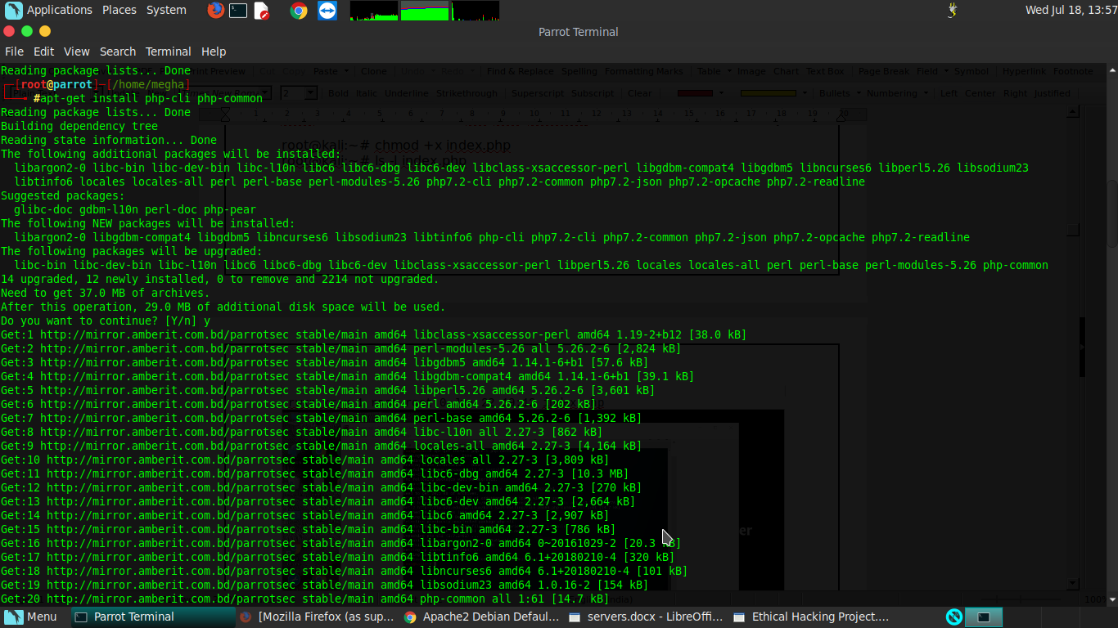

**FTP SERVICE**

─[✗]─[root@parrot]─[/home/megha]

└──╼ #apt-get install vsftpd

Reading package lists... Done

Building dependency tree

Reading state information... Done

The following NEW packages will be installed:

vsftpd

0 upgraded, 1 newly installed, 0 to remove and 2214 not upgraded.

Need to get 152 kB of archives.

After this operation, 353 kB of additional disk space will be used.

Get:1 http://mirror.amberit.com.bd/parrotsec stable/main amd64 vsftpd amd64 3.0.3-9 [152 kB]

Fetched 152 kB in 6s (25.0 kB/s)

Preconfiguring packages ...

Selecting previously unselected package vsftpd.

(Reading database ... 419163 files and directories currently installed.)

Preparing to unpack .../vsftpd_3.0.3-9_amd64.deb ...

Unpacking vsftpd (3.0.3-9) ...

Setting up vsftpd (3.0.3-9) ...

Created symlink /etc/systemd/system/multi-user.target.wants/vsftpd.service → /lib/systemd/system/vsftpd.service.

update-rc.d: We have no instructions for the vsftpd init script.

update-rc.d: It looks like a network service! YOU SHALL NOT PASS!

insserv: warning: current start runlevel(s) (empty) of script `vsftpd' overrides LSB defaults (2 3 4 5).

insserv: warning: current stop runlevel(s) (0 1 2 3 4 5 6) of script `vsftpd' overrides LSB defaults (0 1 6).

Processing triggers for systemd (235-2) ...

Processing triggers for man-db (2.7.6.1-2) ...

Configuring sandbox profiles....

Sandbox profiles updated!

┌─[root@parrot]─[/home/megha]

└──╼ #service vsftpd restart

┌─[root@parrot]─[/home/megha]

└──╼ #ftp

bash: ftp: command not found

┌─[✗]─[root@parrot]─[/home/megha]

└──╼ #service vsftpd status

● vsftpd.service - vsftpd FTP server

Loaded: loaded (/lib/systemd/system/vsftpd.service; disabled; vendor preset: enabled)

Active: active (running) since Wed 2018-07-18 13:59:43 IST; 37s ago

Process: 12584 ExecStartPre=/bin/mkdir -p /var/run/vsftpd/empty (code=exited, status=0/SUCCESS)

Main PID: 12585 (vsftpd)

Tasks: 1 (limit: 4915)

CGroup: /system.slice/vsftpd.service

└─12585 /usr/sbin/vsftpd /etc/vsftpd.conf

Jul 18 13:59:43 parrot systemd[1]: Starting vsftpd FTP server...

Jul 18 13:59:43 parrot systemd[1]: Started vsftpd FTP server.

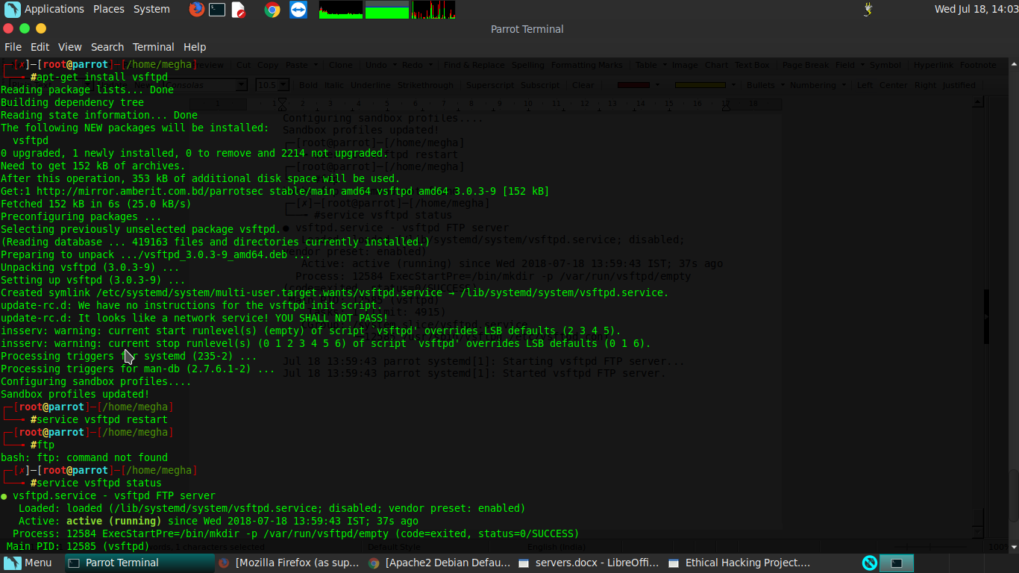

**Commands used:-**

1)apt-get install vsftpd – to install the vsftpd service.

2)service vsftpd restart – to restart the vsftpd service.

3) service vsftpd status – to check the status of the service.

Now open the Browser and open the local host server:-

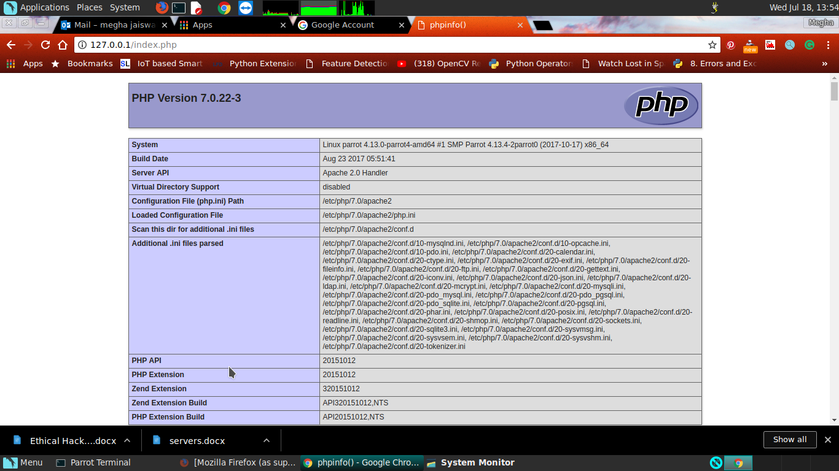

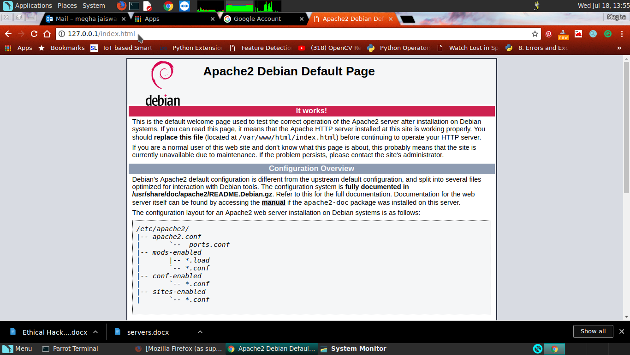

**APPLYING FIREWALL**

┌─[root@parrot]─[/home/megha]

└──╼ #apt-get install firewalld

Reading package lists... Done

Building dependency tree

Reading state information... Done

The following additional packages will be installed:

ebtables ipset libipset3

The following NEW packages will be installed:

ebtables firewalld ipset libipset3

0 upgraded, 4 newly installed, 0 to remove and 2214 not upgraded.

Need to get 633 kB of archives.

After this operation, 4,133 kB of additional disk space will be used.

Do you want to continue? [Y/n] y

Get:1 http://mirror.amberit.com.bd/parrotsec stable/main amd64 ebtables amd64 2.0.10.4-5 [87.6 kB]

Get:2 http://mirror.amberit.com.bd/parrotsec stable/main amd64 firewalld all 0.4.4.6-2 [438 kB]

Get:3 http://mirror.amberit.com.bd/parrotsec stable/main amd64 libipset3 amd64 6.34-1 [58.4 kB]

Get:4 http://mirror.amberit.com.bd/parrotsec stable/main amd64 ipset amd64 6.34-1 [49.4 kB]

Fetched 633 kB in 22s (28.3 kB/s)

Selecting previously unselected package ebtables.

(Reading database ... 419221 files and directories currently installed.)

Preparing to unpack .../ebtables_2.0.10.4-5_amd64.deb ...

Unpacking ebtables (2.0.10.4-5) ...

Selecting previously unselected package firewalld.

Preparing to unpack .../firewalld_0.4.4.6-2_all.deb ...

Unpacking firewalld (0.4.4.6-2) ...

Selecting previously unselected package libipset3:amd64.

Preparing to unpack .../libipset3_6.34-1_amd64.deb ...

Unpacking libipset3:amd64 (6.34-1) ...

Selecting previously unselected package ipset.

Preparing to unpack .../ipset_6.34-1_amd64.deb ...

Unpacking ipset (6.34-1) ...

Setting up firewalld (0.4.4.6-2) ...

update-alternatives: using /usr/share/polkit-1/actions/org.fedoraproject.FirewallD1.server.policy.choice to provide /usr/share/polkit-1/actions/org.fedoraproject.FirewallD1.policy (org.fedoraproject.FirewallD1.policy) in auto mode

Created symlink /etc/systemd/system/dbus-org.fedoraproject.FirewallD1.service → /lib/systemd/system/firewalld.service.

Created symlink /etc/systemd/system/multi-user.target.wants/firewalld.service → /lib/systemd/system/firewalld.service.

update-rc.d: We have no instructions for the firewalld init script.

update-rc.d: It looks like a non-network service, we enable it.

Setting up libipset3:amd64 (6.34-1) ...

Processing triggers for libc-bin (2.27-3) ...

Setting up ipset (6.34-1) ...

Processing triggers for systemd (235-2) ...

Setting up ebtables (2.0.10.4-5) ...

Created symlink /etc/systemd/system/multi-user.target.wants/ebtables.service → /lib/systemd/system/ebtables.service.

Processing triggers for man-db (2.7.6.1-2) ...

Processing triggers for dbus (1.11.22-1) ...

Processing triggers for systemd (235-2) ...

Configuring sandbox profiles....

Sandbox profiles updated!

┌─[root@parrot]─[/home/megha]

└──╼ # service firewalld restart

┌─[root@parrot]─[/home/megha]

└──╼ #firewall-cmd --permanent --add-service=ftp

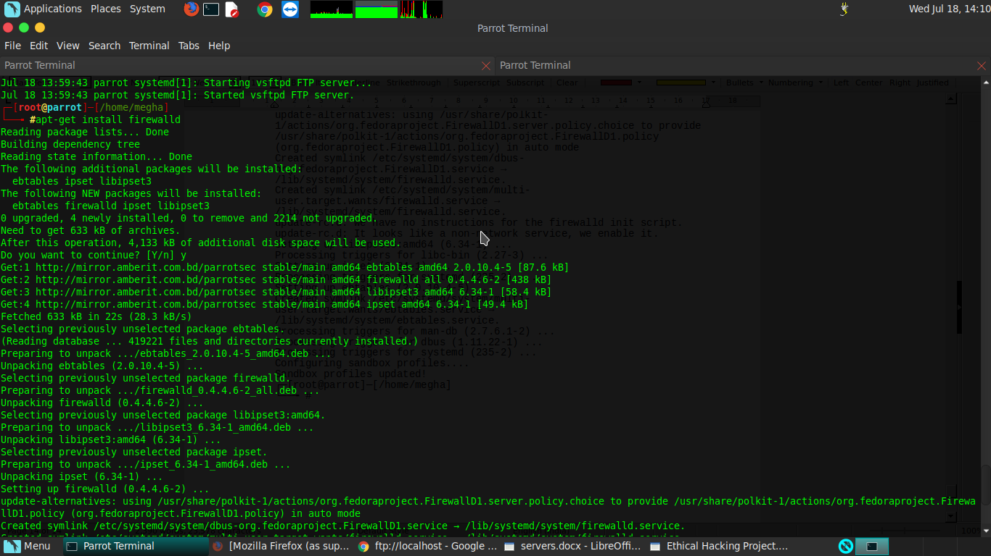

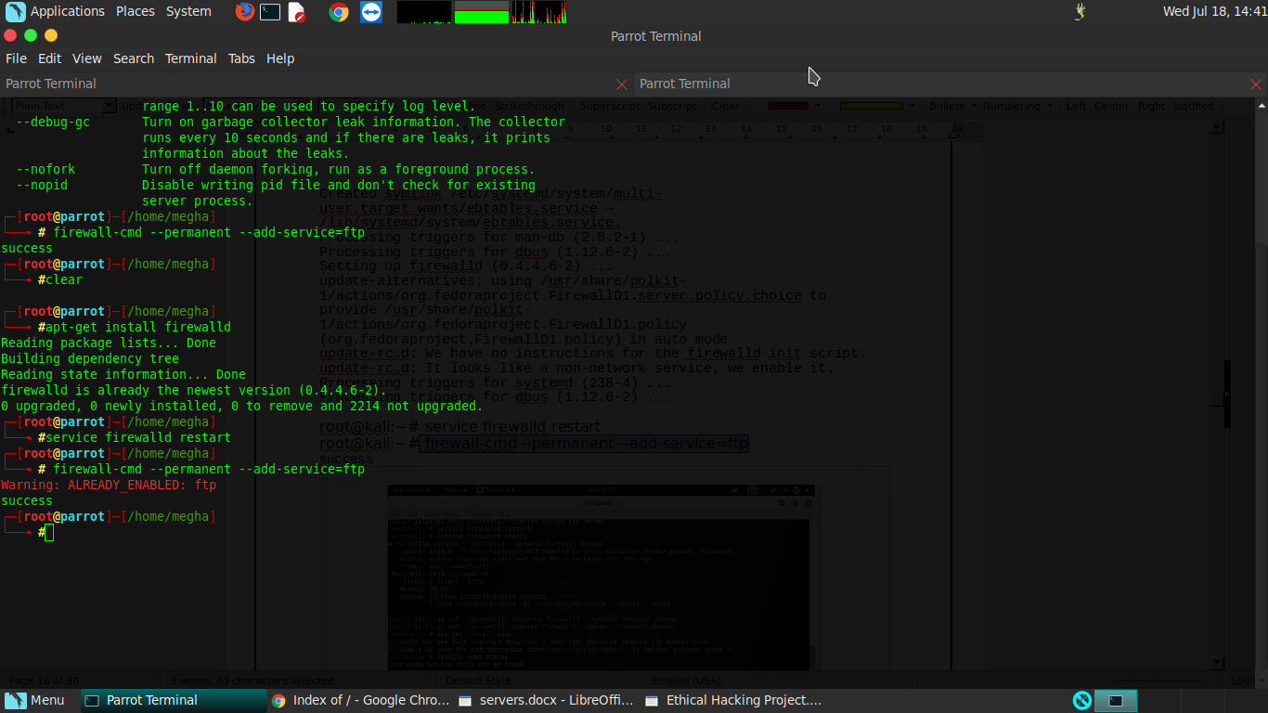

**Commands Used:-**

1. apt-get install firewalld - to install the service firewalld .
2. service firewalld restart - to restart the service .
3. Firewall -cmd –permanent –add -service=ftp - to provide the security to the server.

**Now open Browser and open** [**ftp://127.0.0.1:-**](ftp://127.0.0.1:-)

